WEB DEVELOPMENT CAPSTONE

PROJECT DETAILS

This project incorporates a complete portfolio consisting of five individual pages. The first page comprises of the name, the different pages tags and the social media link. The second page entails a brief description about myself along with the skills I have acquired. The next page provides a summary of my resume along with the different certificates that I am rewarded with for individual skills. Page four entails my portfolio which consists of the photographs that I have taken and the pictures that I have drawn. The last page gives you the contact details.

This portfolio is made with the help of bootstrap 4 framework. It is fully responsive (mobile view to desktop view). The portfolio uses the font awesome family to provide fonts. The web accessibility is validated by chrome wave evaluation extension. The html is validated by w3 validator; the screenshots will be provided below.

>>>W3-Validated

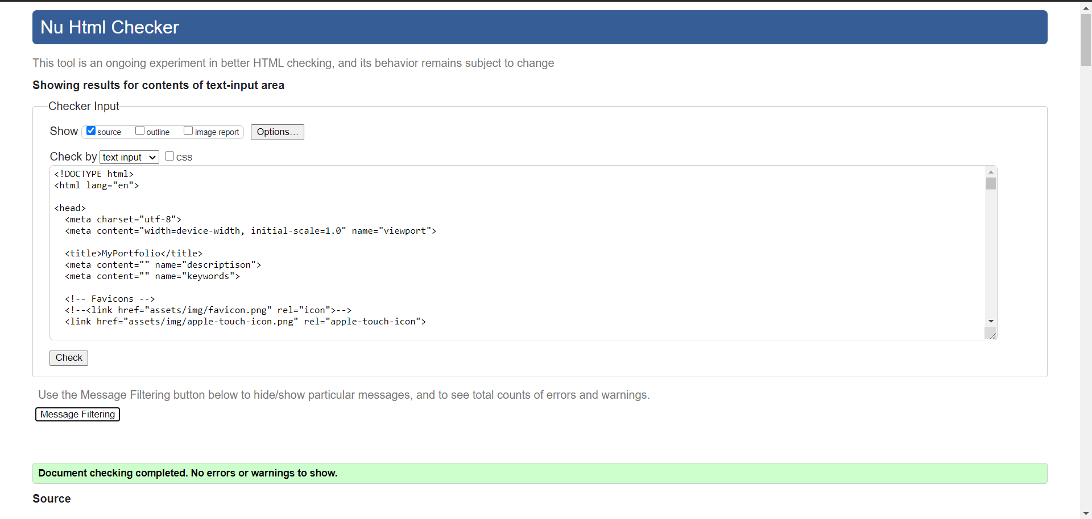

>>>Responsive

